**Wind Energy Conversion Systems**

**Assignment 4**

**M.Shamaas**

**ID # 2018-MS-EE-4**

**Introduction**

This case study investigates the operation of the grid-tied two level inverter with Voltage Oriented Control and Reactive Power Control. The 2.3MW/690V grid-connected inverter is controlled by the VOC scheme with a decoupled PI controller and Space Vector Modulation.

The αβ stationary reference frame is derived from abc- space vectors by putting θ = 0 and . The transformation of three-phase variables, in the stationary reference frame into the two-phase variables, also in the stationary frame is often referred to as abc/αβ transformation:

Similarly, the two-phase to three-phase transformation in the stationary reference frame, known as αβ/abc transformation, can be performed by:

The dq-axis synchronous reference frame variables can be obtained from abc-vectors by decomposing the voltage and current space-vectors into their corresponding d- and q-axis components.

where is the angle between a- and d- axis.

The grid synchronous reference frame is derived from abc-axis stationary reference frame by putting θ = :

Similarly, the two-phase to three-phase transformation in the stationary reference frame, known as dq/abc transformation, can be performed by:

where the grid phase a voltage angle is given by:

so that the grid voltage space vector is coincident with d- axis and rotates at a speed of:

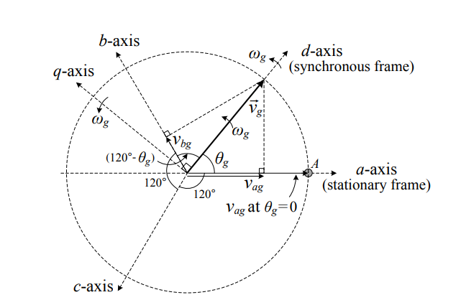

**Part 1: Operation of Grid-Connected Inverter with VOC and Reactive Power Control**

A three-phase two-level voltage source converter is composed of six switches with an anti-parallel free-wheeling diode with each switch. It converts a fixed dc voltage to a three-phase ac voltage with variable magnitude and frequency for an ac load or grid connection. The power flow in the converter circuit is bidirectional: the power can flow from its dc side to the ac side, and vice versa. It delivers the power generated from the generator to the grid. The grid-connected or grid-tied inverter normally delivers power from its dc side to the ac side.

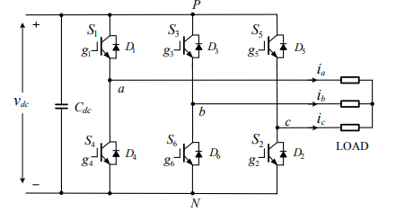

Space vector modulation (SVM) is a real-time modulation technique widely used for digital control of voltage source inverters. The operating status of the switches in the two-level inverter can be represented by switching states. The switching state ‘P’ denotes that the upper switch in an inverter leg is on and the inverter terminal voltage is positive (+Vdc) while ‘O’ indicates that the inverter terminal voltage is zero due to the conduction of the lower switch. There are eight possible combinations of switching states in the two-level inverter. Among the eight switching states, [PPP] and [OOO] are zero states and the others are active states.

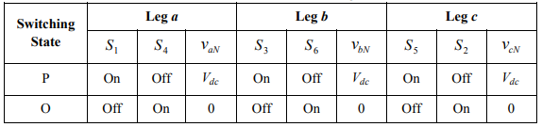

The active and zero switching states can be represented by active and zero space vectors, respectively in the αβ reference frame. The space vector diagram below represents the six active vectors which form a regular hexagon with six equal sectors (I to VI). The zero vector V0 lies on the center of the hexagon.

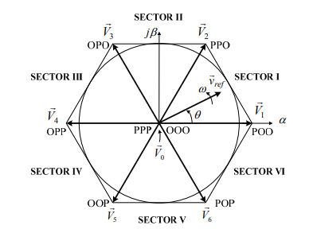

where k represents the sector.

For a given magnitude and position, can be synthesized by three nearby stationary vectors (OOO, POO and PPO in sector 1), based on which the switching states of the inverter can be selected, and gate signals for the active switches can be generated. When passes through sectors one by one, different sets of switches will be turned on or off. As a result, when rotates one revolution in space, the inverter output voltage varies one cycle over time.

The inverter output frequency corresponds to the rotating speed of while its output voltage can be adjusted by the modulation index:

The dwell time for the stationary vectors represents the duty-cycle time of the chosen switches during a sampling period Ts. The dwell time calculation is based on ‘volt-second balancing’ principle, that is, the product of the reference voltage and sampling period Ts equals the sum of the voltage multiplied by the time interval of chosen space vectors. Assuming that the sampling period Ts is sufficiently small, the reference vector ref v r can be considered constant during Ts. Under this assumption, can be approximated by two adjacent active vectors and one zero vector. Ta , Tb and T0 are the dwell times for the vectors , and , respectively:

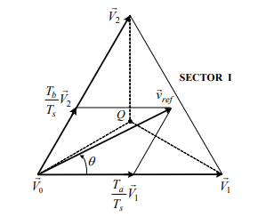

When is in other sectors, a multiple of π 3/ is subtracted from the actual angular displacement θ such that the modified angle θ ′ falls into the range between zero and π 3/ for use in the equation, that is,

for 0 ≤ θ′ <

where k = 1, 2, …6 for sectors I, II, …, VI, respectively. For example, when is in sector II, the calculated dwell times Ta, Tb and T0 are for vectors , and respectively.

With the space vectors selected and their dwell times calculated, the next step is to arrange switching sequence. In general, the switching sequence design for a given is not unique, but it should satisfy the following two requirements for the minimization of the device switching frequency:

a) The transition from one switching state to the next involves only two switches in the same inverter leg, one being switched on and the other switched off;

b) The transition for ref v r moving from one sector in the space vector diagram to the next requires no or minimum number of switching.

The optimized seven segment switching sequence is given in the table below.

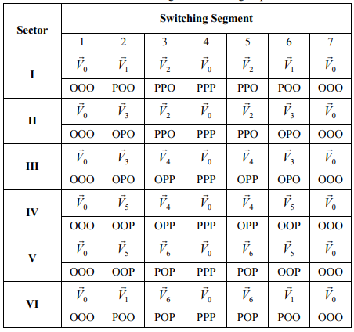

The overall Space Vector Modulation block diagram is given below.

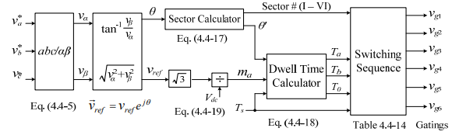

VSI Constants

1. Rated Power
2. Line-Line Voltage
3. Rated Current
4. Base Impedance
5. Rated Frequency
6. DC Link Resistance
7. DC Battery Voltage
8. Line Inductance
9. DC reference voltage
10. Sampling Frequency
11. Grid voltage

The DC Battery voltage starts decreasing at t=0.05s to reduce active power delivered to grid to 0.8 p.u.

The reactive power reference starts decreasing from 0 p.u. to -0.5 p.u. at t=0.15s

Simulink Model

The input variables of the model include the dq-axis stator voltages vds and vqs, rotor voltages vdr and vqr, the mechanical torque Tm, and the speed of the arbitrary reference frame w. The output variables are dq-axis stator currents, ids and iqs, the electromagnetic torque Te, and the mechanical speed wm of the generator.

1. Block diagram for dynamic simulation of Two Level Voltage Source Inverter.

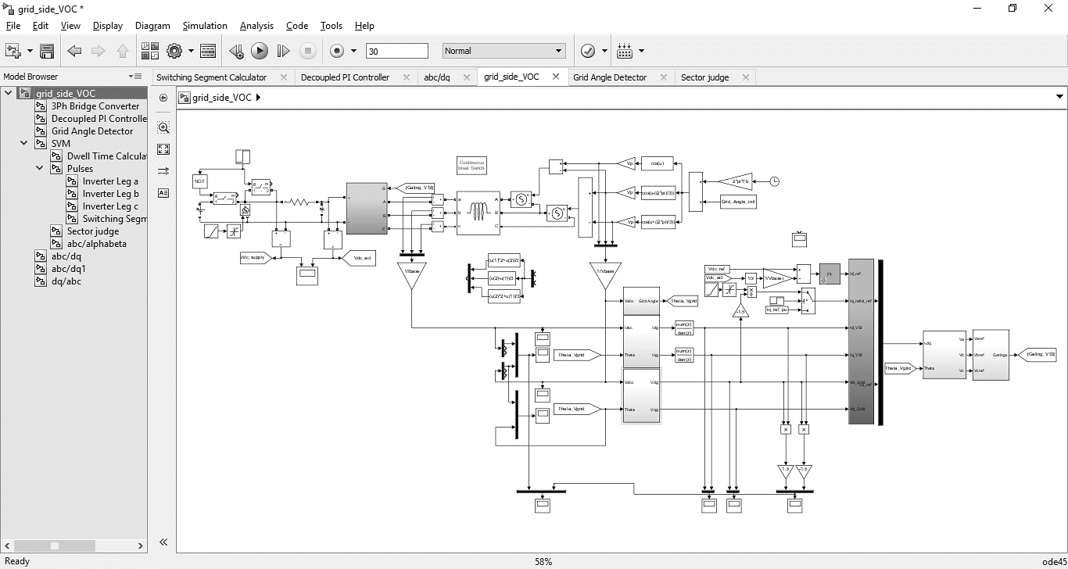

1. 3 phase Inverter Circuit Diagram

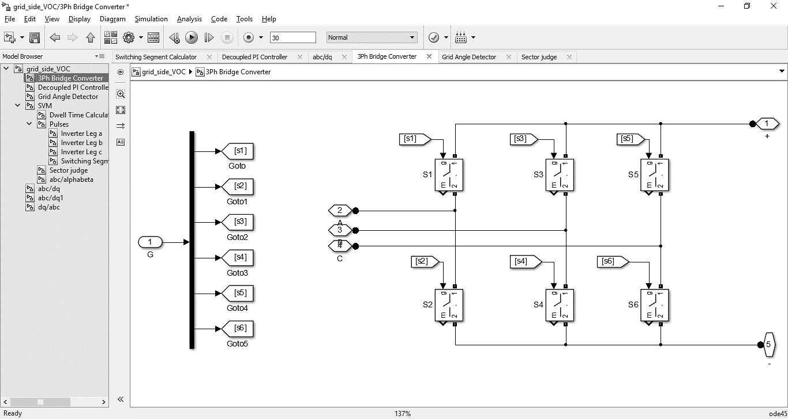

1. Decoupled current controller Block Diagram

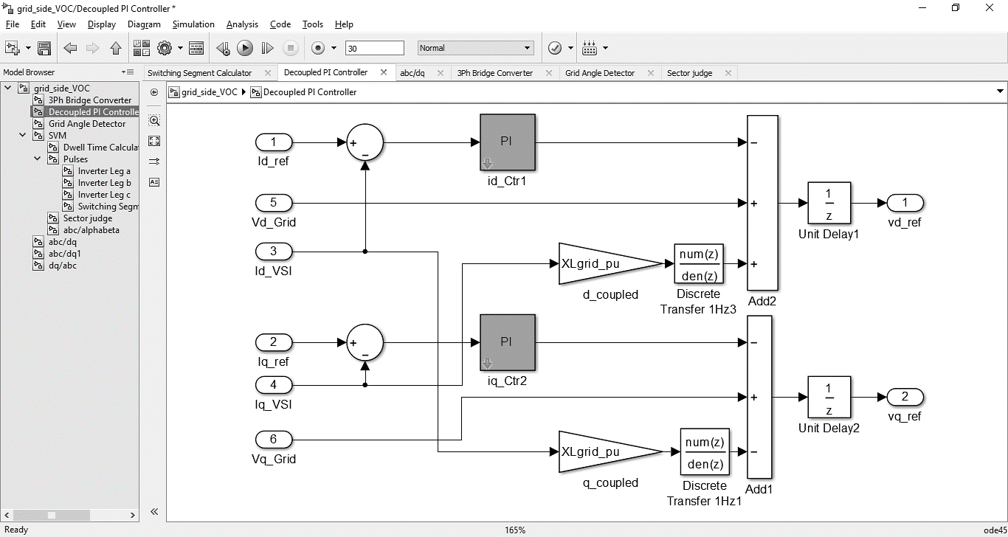

1. Grid Angle Detector

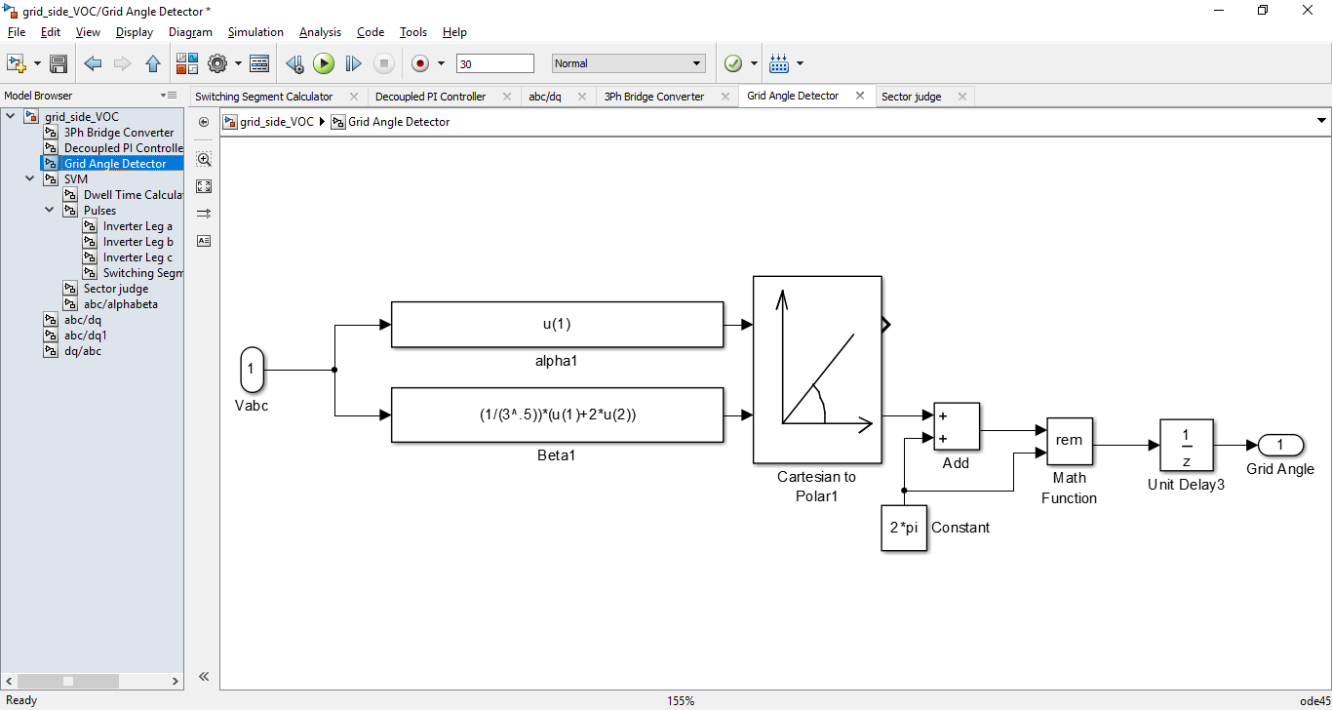

1. Space Vector Modulator

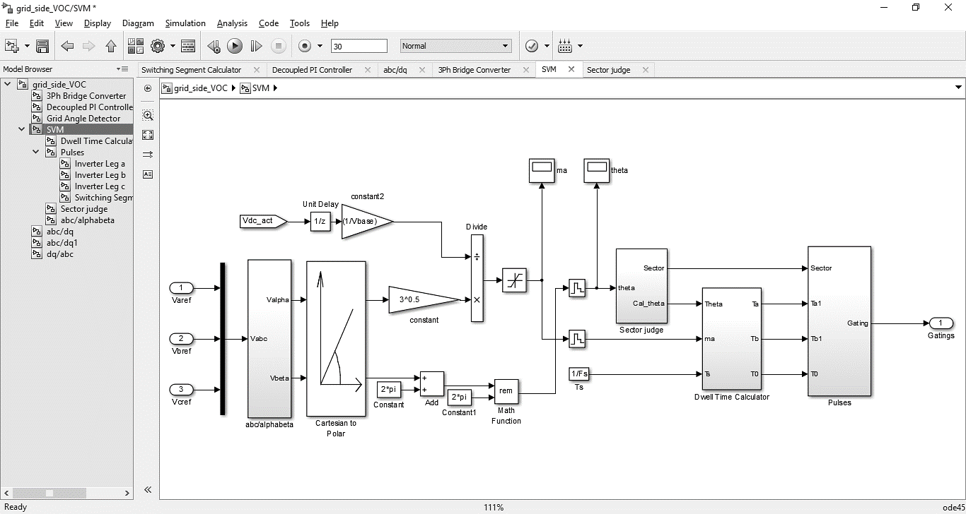

1. Dwell Time Calculator

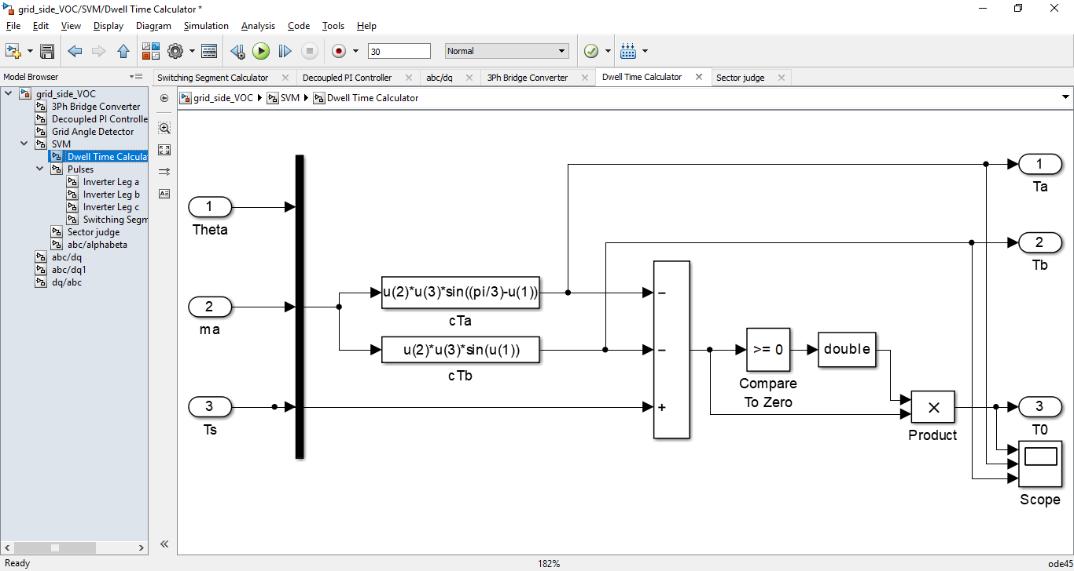

1. Sector Judge

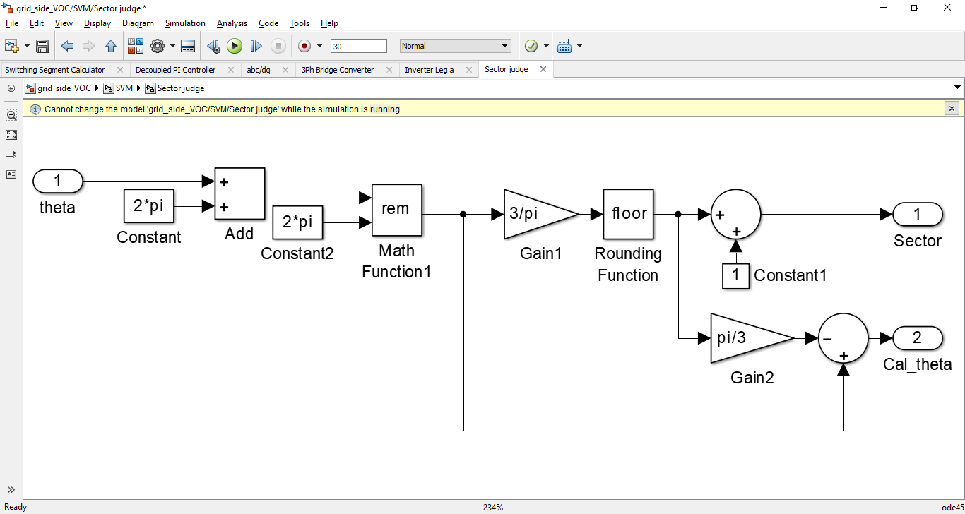

1. Switching Segment Calculator, Segment Pulses Selector and Sector Pulse Selector for Switching Sequence Generator

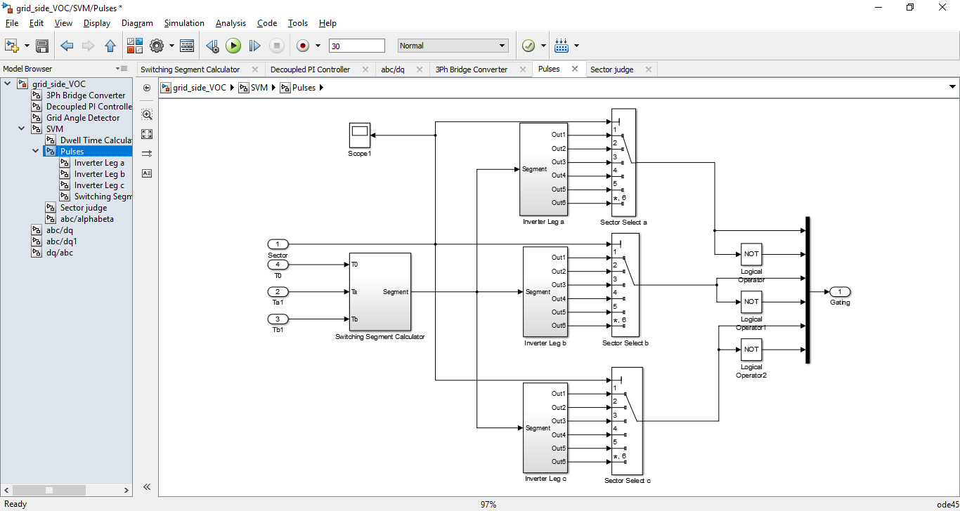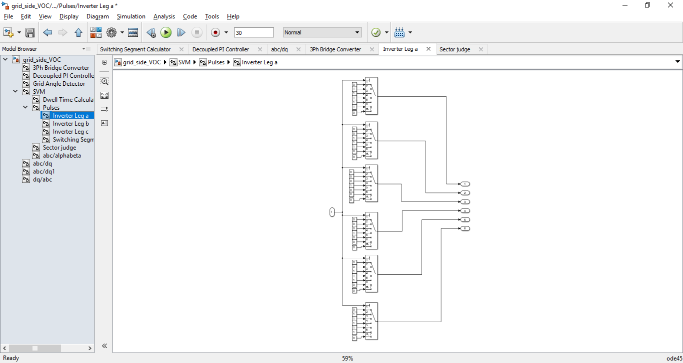

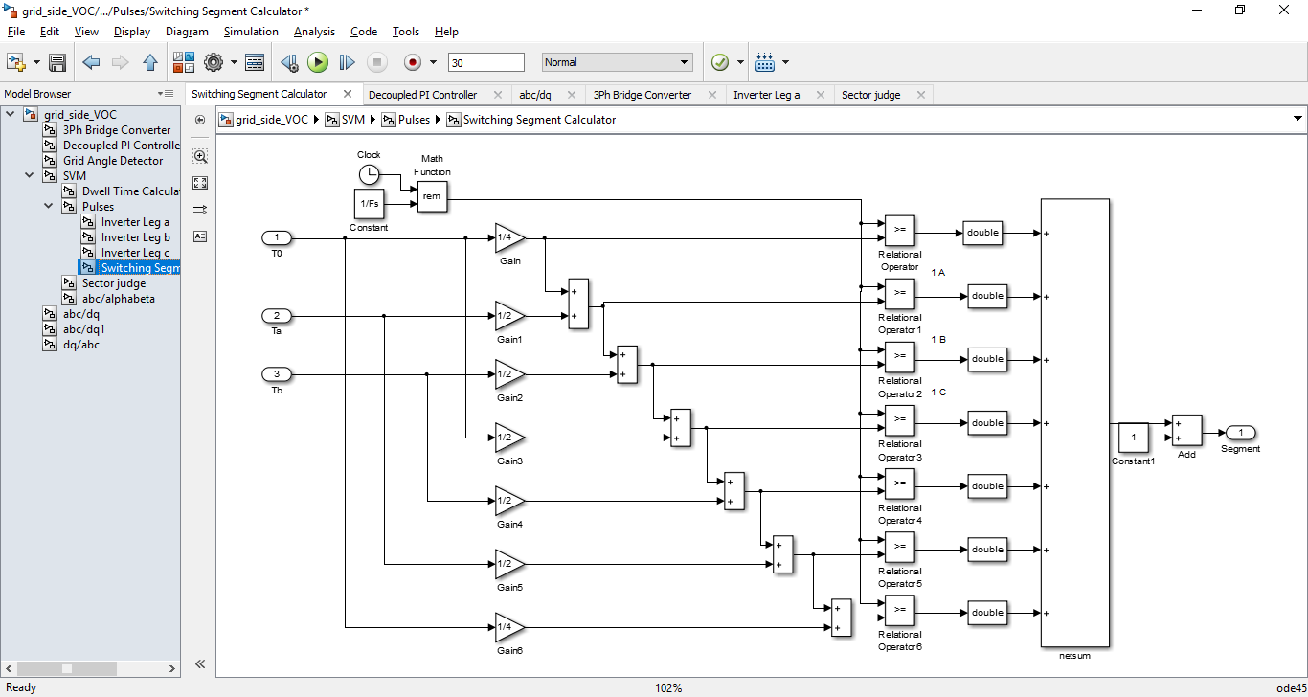

1. abc/αβ transformation, abc/dq transformation and dq/abc transformation

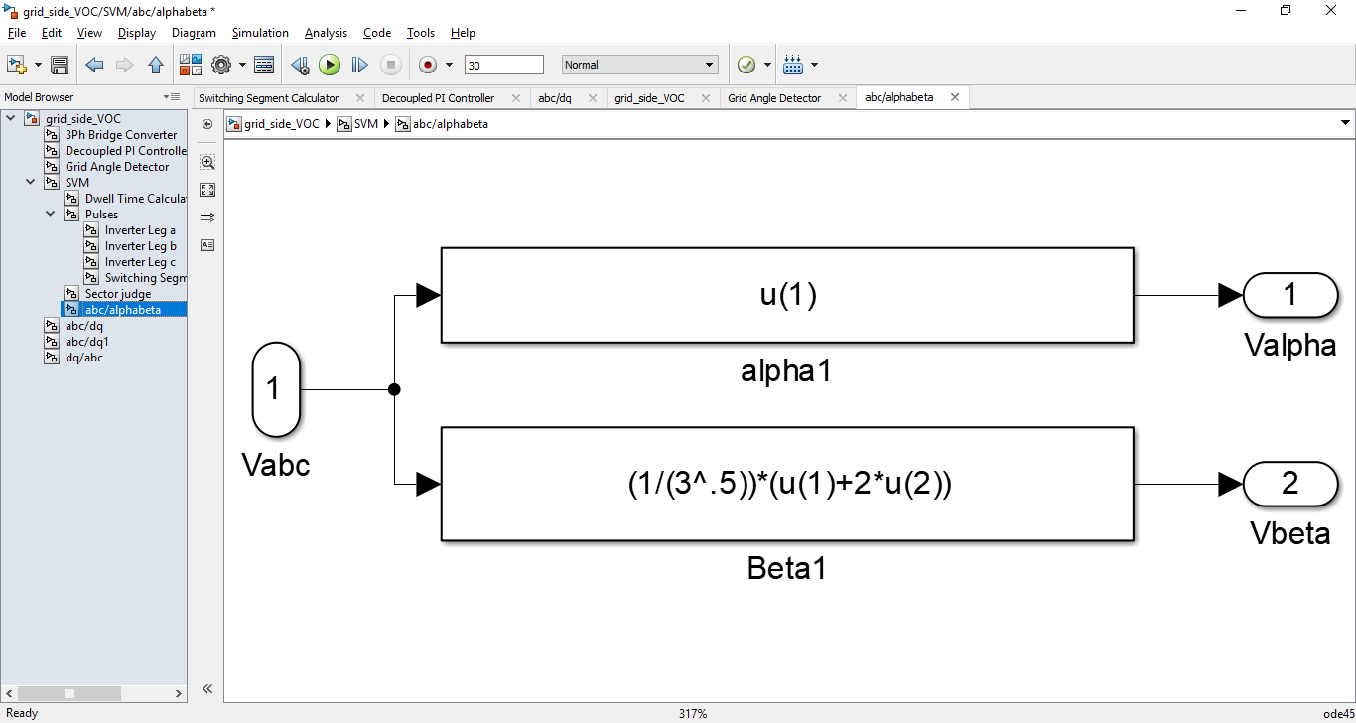

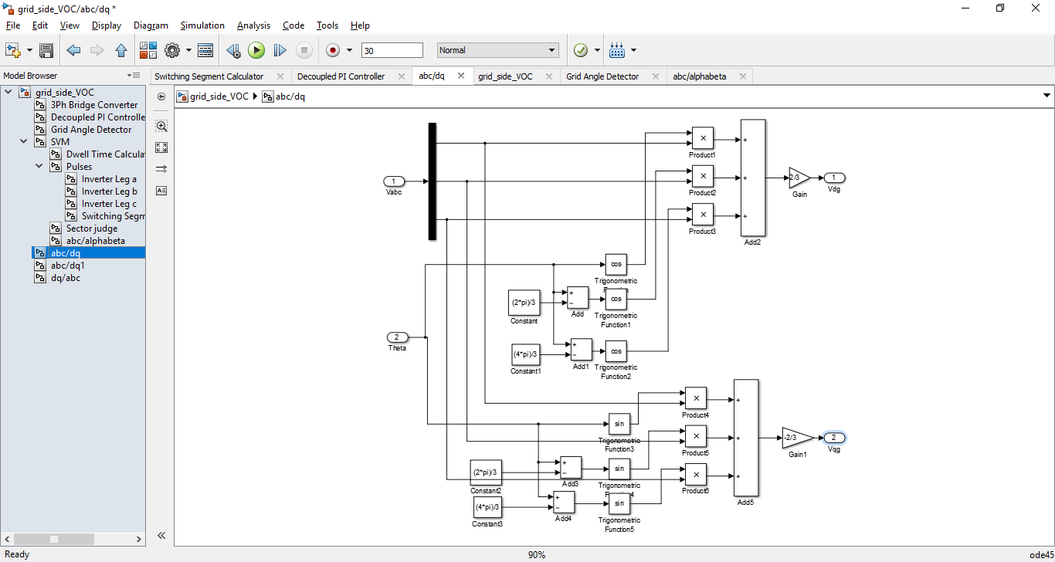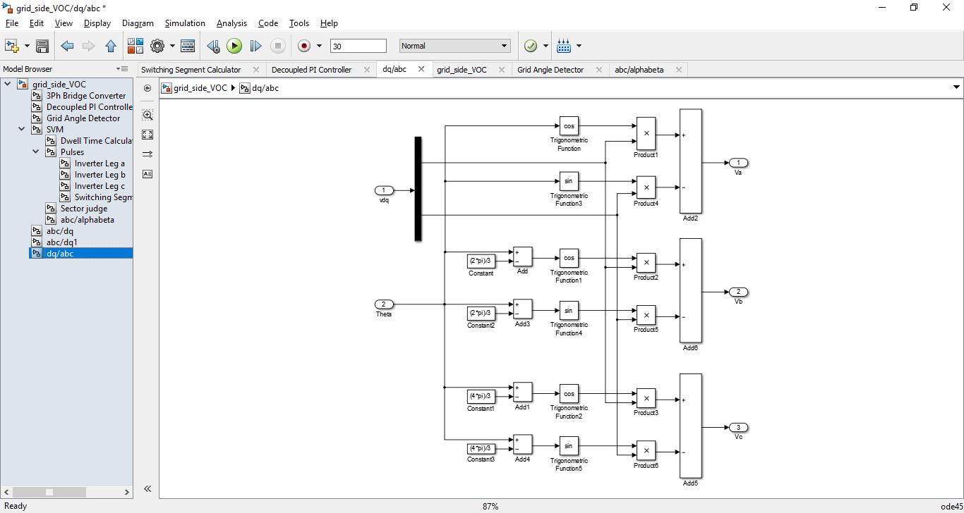

MATLAB Code

clc

clear

F0=1;

Grid_Angle_init = pi;

iq_ref_pu = 0;

% rectifier or inverter selection

% "1" --- rectifier

% "0" --- inverter

Rectifier_or_inverter=0;

Pb=2.3e6;

Vp= (690*(2^0.5))/ (3^0.5);

Vbase=Vp/ (2^.5);

Fb=60;

Ibase=(Pb/3)/ (690/ (3^0.5));

Zb=Vbase/Ibase;

Omega_b=2*pi*Fb;

XLb=Zb;

XCb=Zb;

% grid-side filter inductor

Lgrid=0.1098e-3;

XLgrid=0.2*XLb;

XLgrid_pu=XLgrid/Zb;

Rgrid_pu=0.1;

Rgrid=Rgrid_pu*Zb;

Power_loss=Rgrid_pu*Pb;

%dc link

XCdc=0.3*XCb;

Cdc=1/(Omega_b*XCdc);

Vdc_ref=3.062; % in per unit

Vdc_capacitor_initial=Vdc_ref*Vbase;

%dc supply voltage calculation according to series resistor

Rdc_series=0.1*Zb; % might be changed here

if Rectifier_or_inverter==1 % for rectifier operation case

Idc= (Pb - Power_loss)/(Vdc_ref*Vbase);

Vdc_supply=Vdc_ref*Vbase - Idc*Rdc_series;

elseif Rectifier_or_inverter==0% for inverter operation case

Idc= (Pb + Power_loss)/(Vdc_ref*Vbase);

Vdc_supply=Vdc_ref*Vbase + Idc*Rdc_series;

end

%switching frequency

Fs=2040; % 34 times fundamental frequency

% sampling frequency for controller

Fsampling=10e3; % at least 2 times Fs recommended

% PI Feedback constants

Kp=1;

Ki=10;

Results

1. vag and

vag has a rms value of 1 p.u. Initially is π.

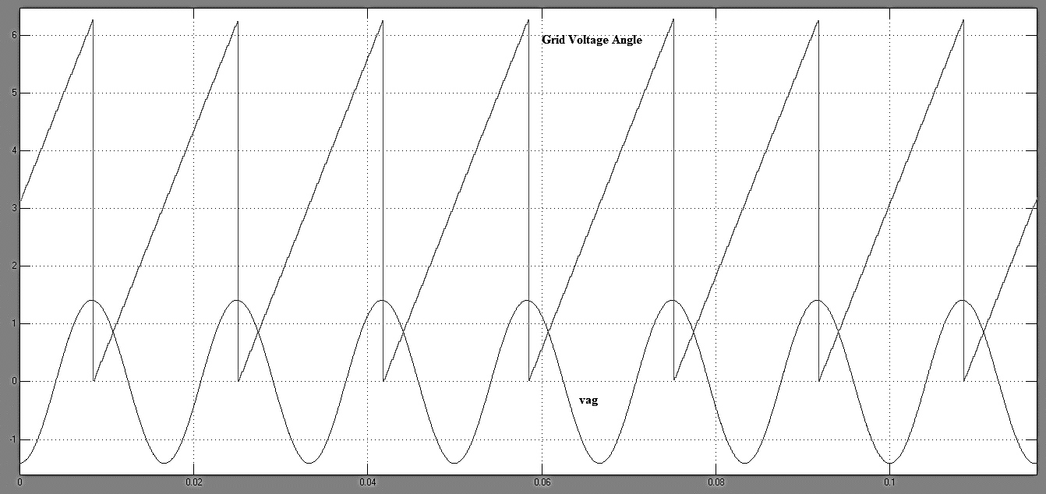

1. Battery Voltage E and DC Link Voltage Vdc

Initially E = 1259 V and it decreases to 1252 V.

Vdc tracks the reference Vdc* = 1220V.

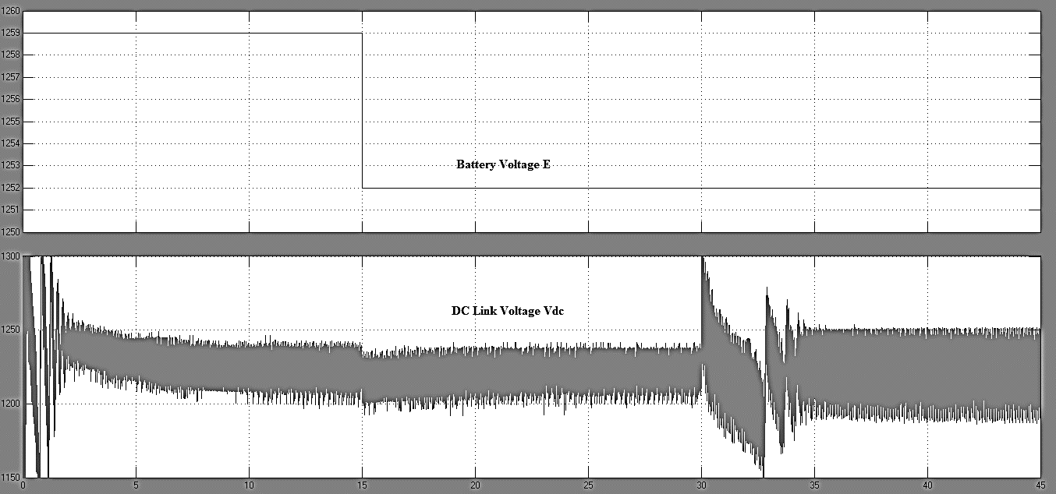

Steady State I

The Battery Voltage is 1259 V. Qg* = 0 p.u. Vdc* = 1220 V.

1. vag, iag, Pg, Qg

vag leads iag by 180°. Qg = 0 p.u. Pg = -1 p.u. The inverter supplies active power to the grid. No reactive power is delivered to the grid since reference Qg* = 0 p.u.

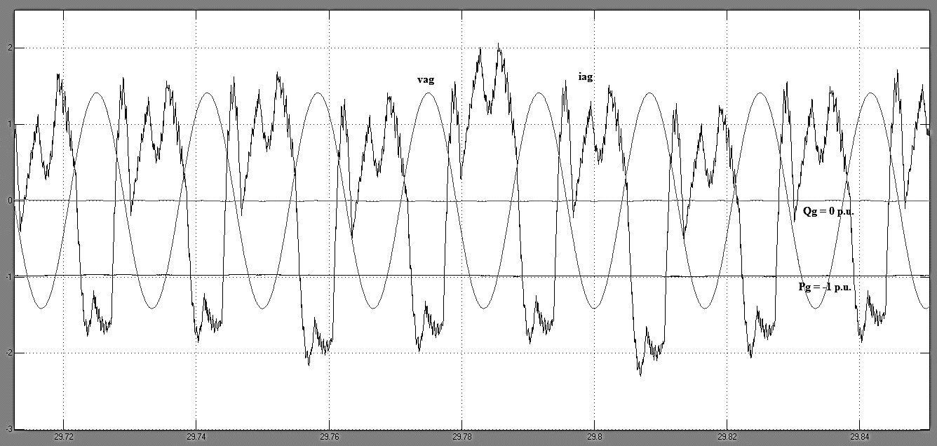

1. idg and iqg

iqg = 0 A and idg = -1.414 A.

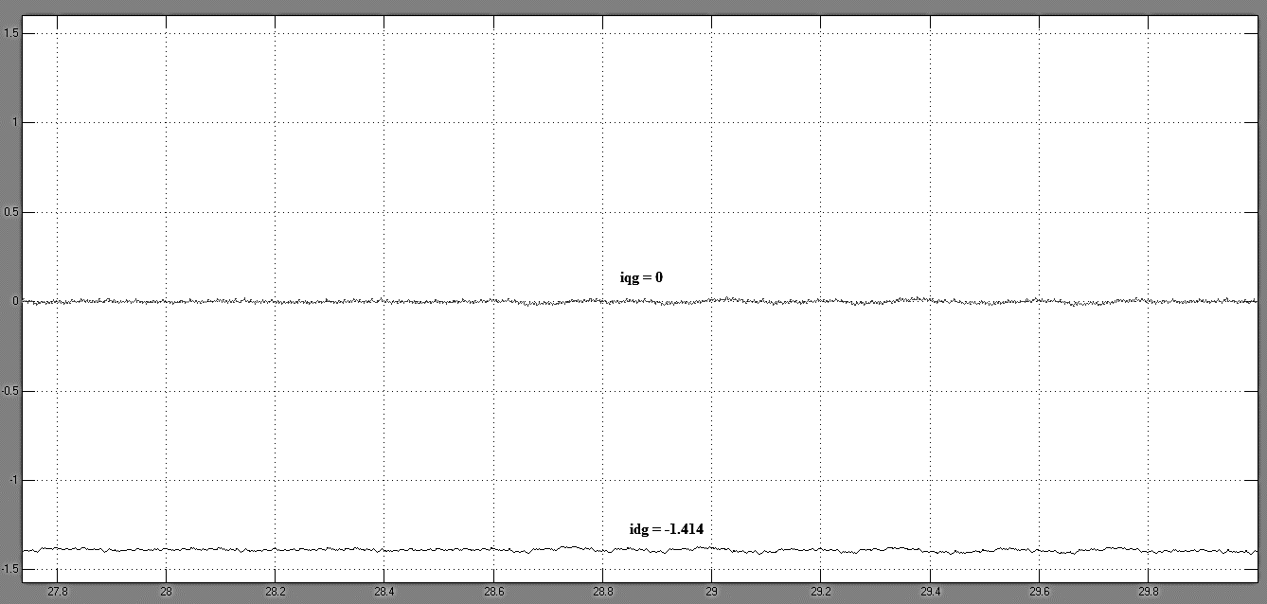

Steady State II

The Battery Voltage decreases to 1252 V. Qg* = 0 p.u. Vdc* = 1220 V.

1. vag, iag, Pg, Qg

vag leads iag by 180°. Qg = 0 p.u. Pg = -0.8 p.u. The inverter supplies active power to the grid. No reactive power is delivered to the grid since reference Qg* = 0 p.u.

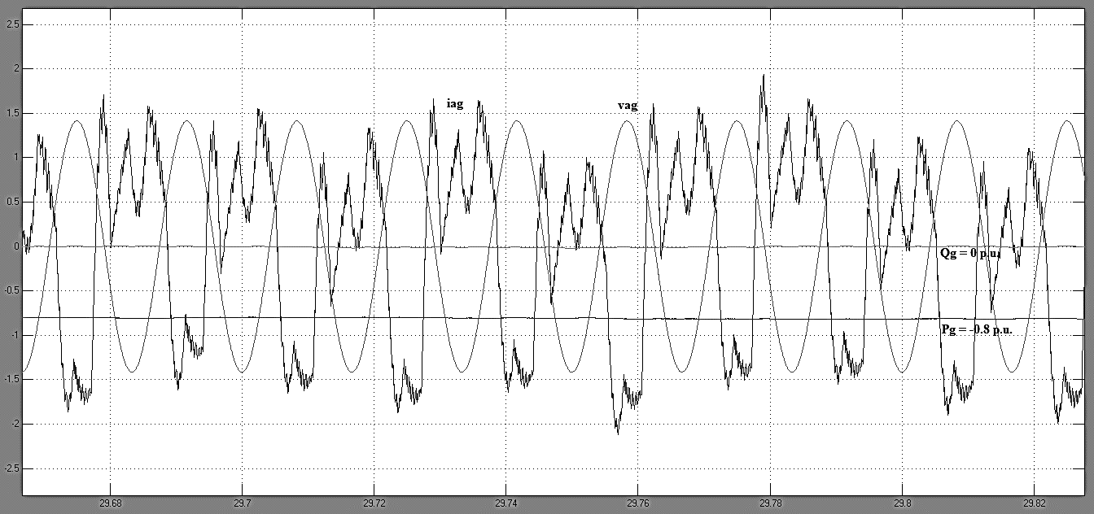

1. idg and iqg

iqg = 0 A and idg = -1.13 A.

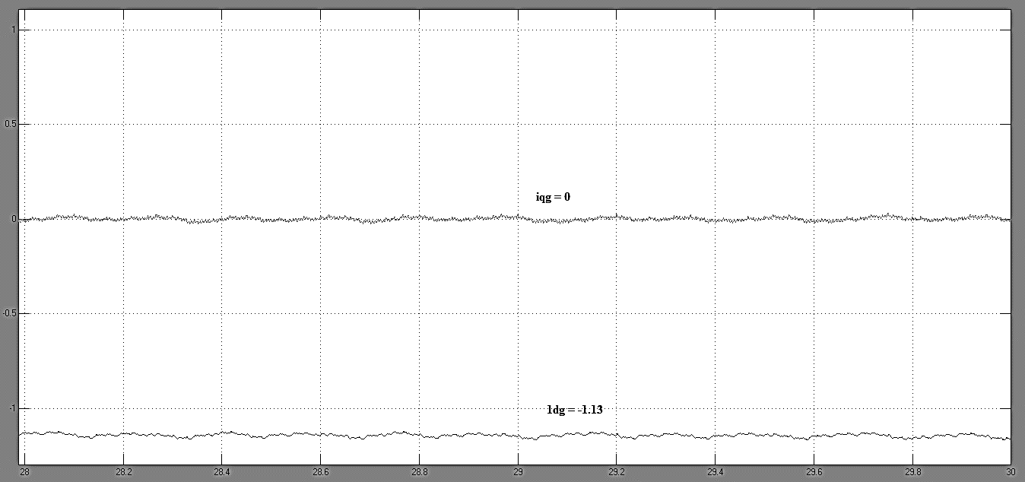

Steady State II

The Battery Voltage remains at 1252 V. Qg* = -0.5 p.u. Vdc* = 1220 V.

1. vag, iag, Pg, Qg

vag leads iag by 212°. Qg = -0.5 p.u. Pg = -0.8 p.u. The inverter supplies active power and reactive power to the grid.

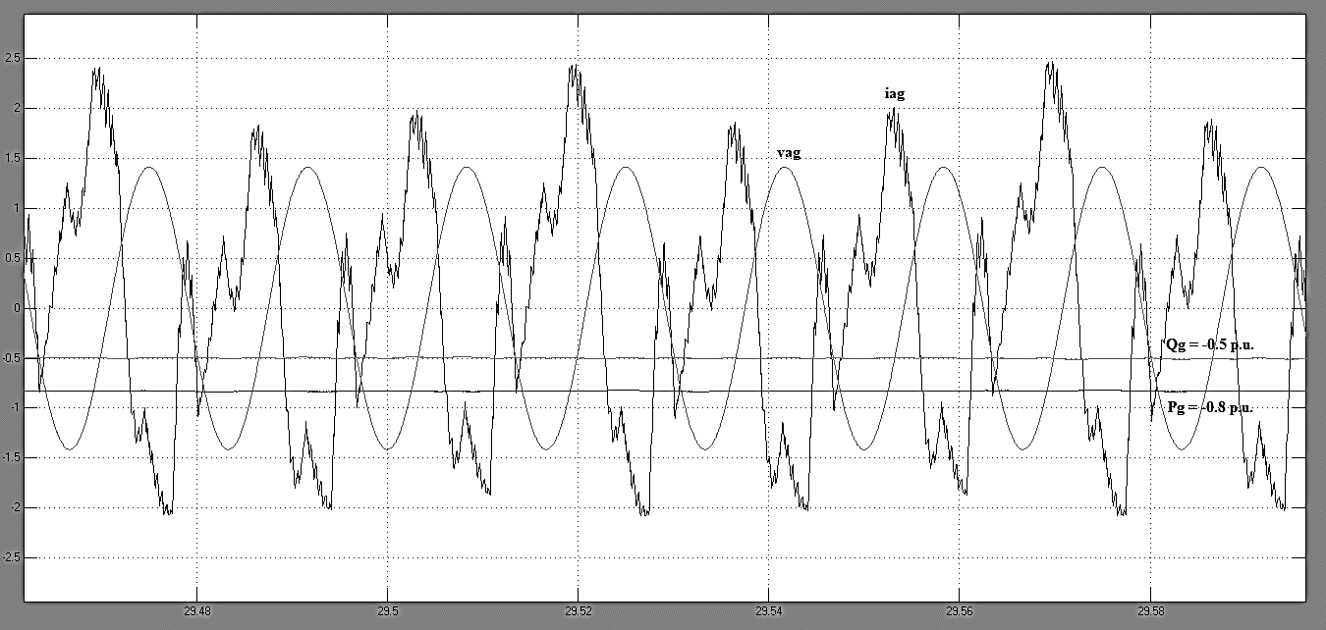

1. idg and iqg

iqg = 0.707 A and idg = -1.13 A.

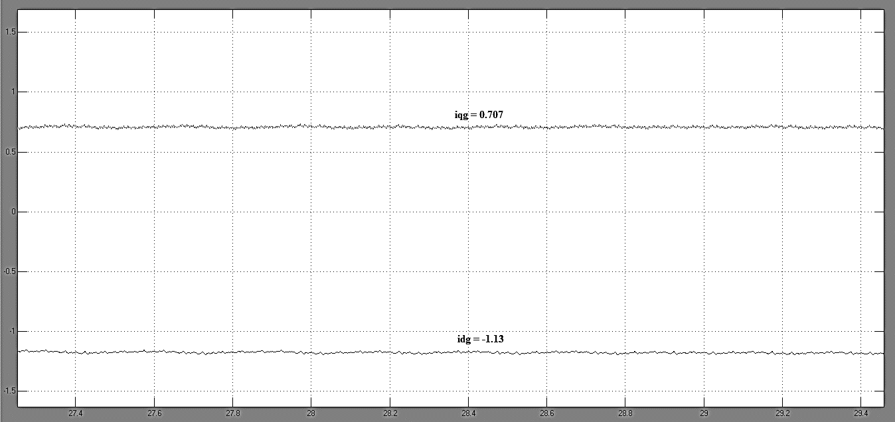

Summary

1. idg and iqg

Steady State 1: iqg = 0 A, idg = -1.414 A

Steady State 2: iqg = 0 A, idg = -1.13 A

Steady State 3: iqg = 0.717 A, idg = -1.13 A

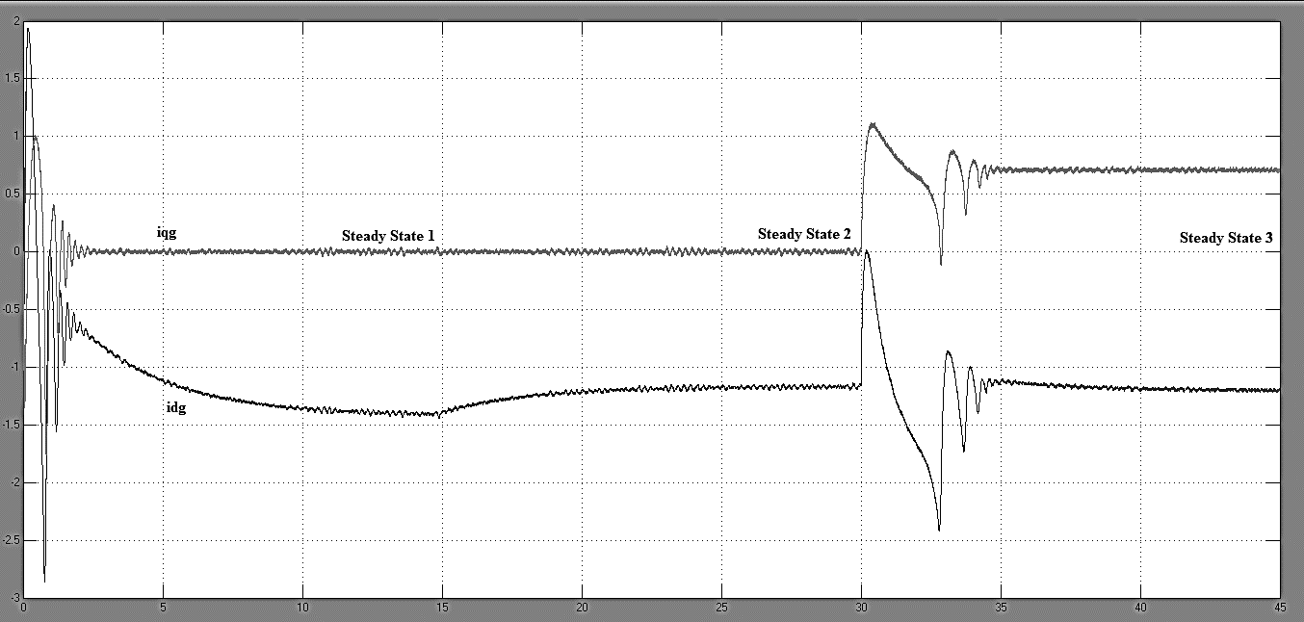

1. Pg and Qg

Steady State 1: Qg = 0 p.u., Pg = -1 p.u.

Steady State 1: Qg = 0 p.u., Pg = -0.8 p.u.

Steady State 1: Qg = -0.5 p.u., Pg = -0.8 p.u.

